# Computer Vision Hw9 Report

* Discription
  + General Edge Detection
* Algorithm
  + Robert, Prewitt, Sobel, Robinson, Frei & Chen, Kirsch , and Nevatia-Babu's edge detectors.
* Parameters (if any)
  + no
* Principal Code Fragment

Main (file – /src/hw9/ DemoGeneralEdgeDetection.java)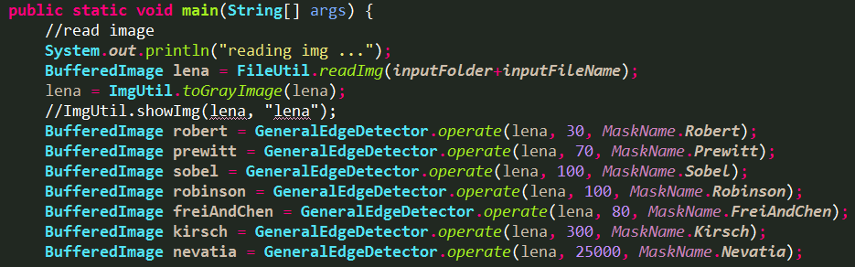

GeneralEdgeDetector

(file – /src/cv1.util.cv.edge /GeneralEdgeDetector.java)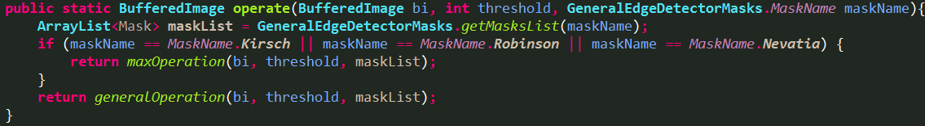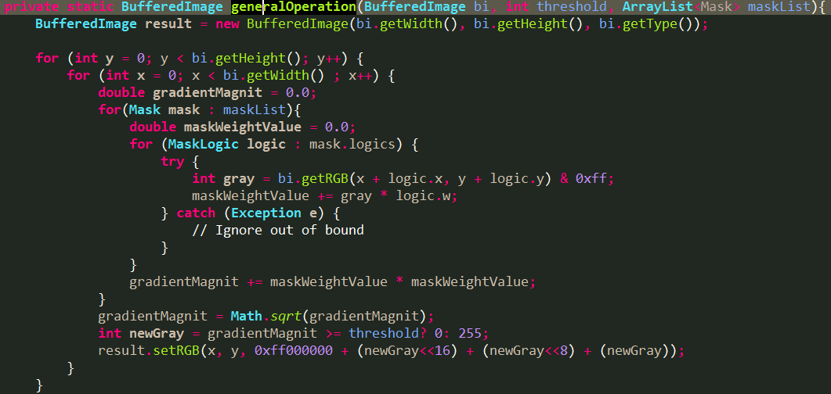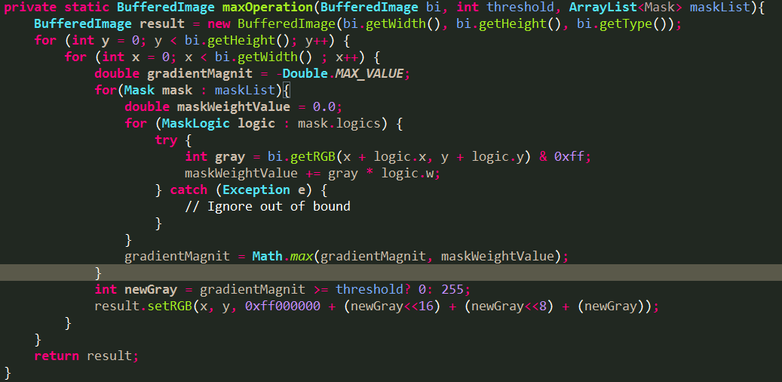

* Result Image

Robert (threshold = 30) Prewitt (threshold = 70)

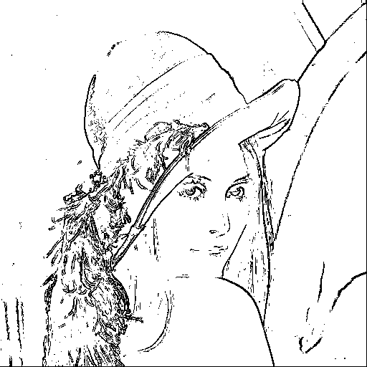 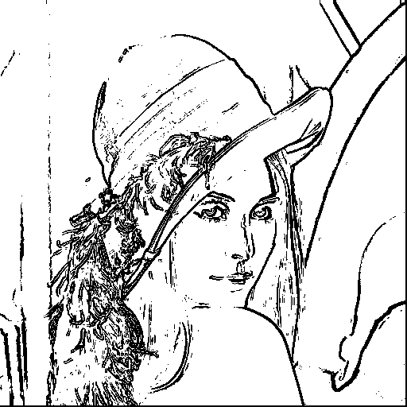

Sobel (threshold = 100) Robinson (threshold = 100)

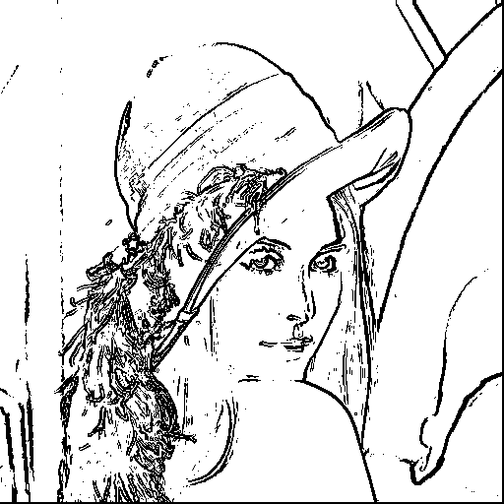 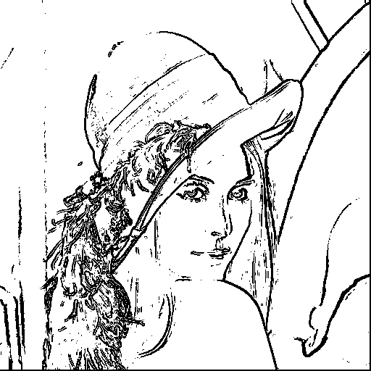

Frei & Chen (threshold = 80) Kirsch (threshold = 300)

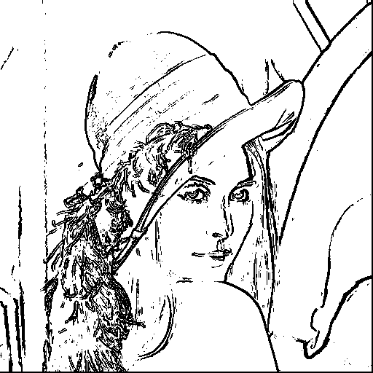 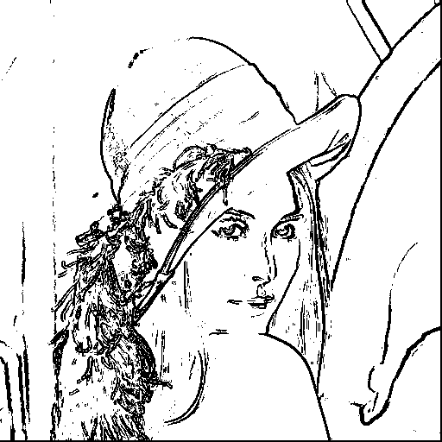

Nevatia-Babu's (threshold = 25000)

